Rotavirus mortalities of pigeons
Since mid-2016, high levels of mortalities in kept pigeons (racing and fancy) have occurred in lofts across some states of Australia (Western Australia, Victoria, New South Wales, South Australia).
Clinical signs in affected birds have included depression, vomiting, diarrhoea, regurgitation and hunched postures. Birds that appeared sick usually died within 12 to 24 hours, with deaths in affected lofts continuing for approximately 7 days (Figure 1).
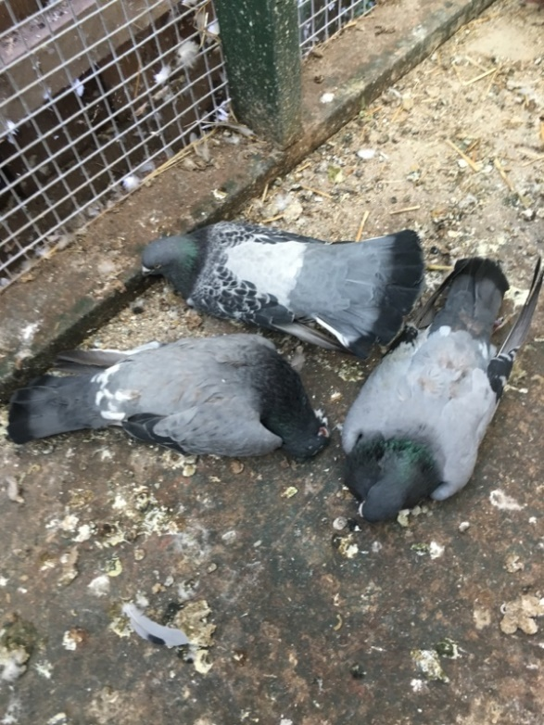
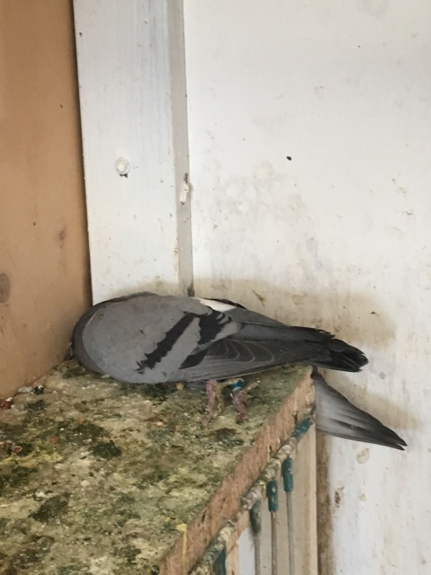
Mortality rates of up to approximately 30% have been reported in affected lofts.

Figure 1: Clinically affected and dead pigeons, noting evidence of green diarrhoea (Images provided by Dr C Walker)
Intensive diagnostic investigations have been undertaken and included:
- histopathology
- electron microscopy
- molecular testing (polymerase chain reaction (PCR), next generation sequencing (NGS))
- viral culture
- bacterial culture.
Emergency animal diseases and notifiable diseases, such as avian influenza (AI), Newcastle disease virus (NDV) and pigeon paramyxovirus virus type 1 (PPMV1), were ruled out as the cause, as were adenovirus and herpes virus. A rotavirus (a member of the reoviridae family) was confirmed (Figure 2).

Gross and histological findings included severe necrotising hepatitis (friable when handled), coalescing hepatocyte degeneration and necrosis, enlarged/pale spleens with severe depletion of lymphoid tissue and reduction in the size of the cloacal bursa.
Laboratory analysis of liver tissue by PCR and histology identified large quantities of virus of the reoviridae family. This finding was confirmed by negative contrast electron microscopy.
Virus isolated from the liver of affected pigeons was inoculated into embryonated chicken eggs. Following the second passage, some pathology was evident. However, when samples of allantoic fluid were examined using negative contrast electron microscopy no virus was observed.
Next generation gene sequencing on liver samples from affected pigeons confirmed a rotavirus (a member of the reoviridae family) of serotype G18P.
Figure 2: Summary of diagnostic investigation findings
Feral pigeons are likely to be susceptible to the virus. Any signs of disease that are unusual or clusters of deaths in wild birds should be reported. In Western Australia, feral pigeon (rock pigeon; Columba livia) mortalities occurred in a location close to an affected loft, with gross and histological findings consistent with the disease in the racing and fancy pigeons. In addition, rotavirus has been detected in faecal samples of several feral and native wild bird species overseas.
To explore the risk of transmission of this rotavirus to other bird species (domestic poultry), challenge trials are planned; however, the risk to the commercial poultry sector has been considered low based on field experience. At this stage, no challenge testing for pigeons is planned.
It is noted that there is currently no indication that the PPMV1 vaccine was involved with this rotavirus disease.
There is no vaccine currently available to protect birds against this rotavirus. There are significant antigenic differences between the isolated pigeon rotavirus and the G10 serotype of the bovine rotavirus vaccine. This means that protection for pigeons from the bovine vaccine is unlikely.
It is understood that the pigeon industry is currently investigating opportunities to develop a new vaccine.
Australia has a rigorous regulatory framework for assessing and approving veterinary vaccines to ensure their safety and efficacy. As part of this, there are strict penalties for the illegal importation and use of veterinary vaccines, including but not limited to up to 10 years imprisonment and fines of up to $1,800,000 under the Biosecurity Act 2015 (Cwlth).
The pigeon industry is advised to implement biosecurity measures to prevent the spread of the disease. This includes reconsidering gatherings and movements (including racing) of pigeons, and practicing good personal biosecurity. The squab industry should also take appropriate measures.
Biosecurity recommendations for the pigeon industry and private veterinarians are available from state departments of agriculture.
Additional general biosecurity resources are also available and include:
- Department of Agriculture and Water Resources - Bird biosecurity information
- National Farm Biosecurity Manual – Poultry Production
- National Zoo Biosecurity Manual
- Australian Veterinary Association Guidelines for veterinary personal biosecurity.
It is important for bird keepers and others to continue to report any suspicious signs of disease. This will also allow the presence of notifiable diseases, including AI, PPMV1 and ND, to be investigated and ruled out.
You can report sick birds (domestic, feral or native) with higher than usual numbers of deaths to your private veterinarian, local state department veterinarian, local state Wildlife Health Australia Coordinator, or the Emergency Animal Disease hotline on 1800 675 888.

https://www.wildlifehealthaustralia.com.au/AboutUs/ContactDetails.aspx

